**Civil Engineering Case Study- Freezing Temperature of Seawater**

***Demarce Williams (dsw9740)***

***ENGR-UH 1000, Fall 2023***

***STEP 1: Problem Identification and. Statement***

The problem is to compute the linear regression model based on a given data set of temperature and salinity readings and estimate the freezing temperatures based on a given salinity value of water using the computed model.

***STEP 2: Gathering of Information and Input and Output Description***

Seawater is primarily water with about 3.5% dissolved material (salts, metals, and gases) from volcanic eruptions and the weathering of rocks. The saltiest ocean waters are in the Atlantic around the equator, where evaporation exceeds precipitation. The salinity of seawater is a measure of the amount of dissolved material in the seawater. Salinity is often measured using an instrument that measures the electrical conductivity of the water; the more dissolved materials in the water, the better it conducts electricity. Measurements of salinity are especially important in colder regions because the temperature at which seawater freezes depends upon its salinity.

The linear regression model between the freezing temperature and the salinity may be represented using the following model:

𝑇 = 𝑚 × 𝑆 + 𝑏

*where, T* is the freezing temperature, *S* is the water salinity, and *m* and *b* are the model parameters. As this is a linear model, m represents the slope/gradient of the model and b represents the y-intercept or the freezing temperature at which the salinity of the seawater is 0.

The model parameters *m* and *b* can be calculated as:

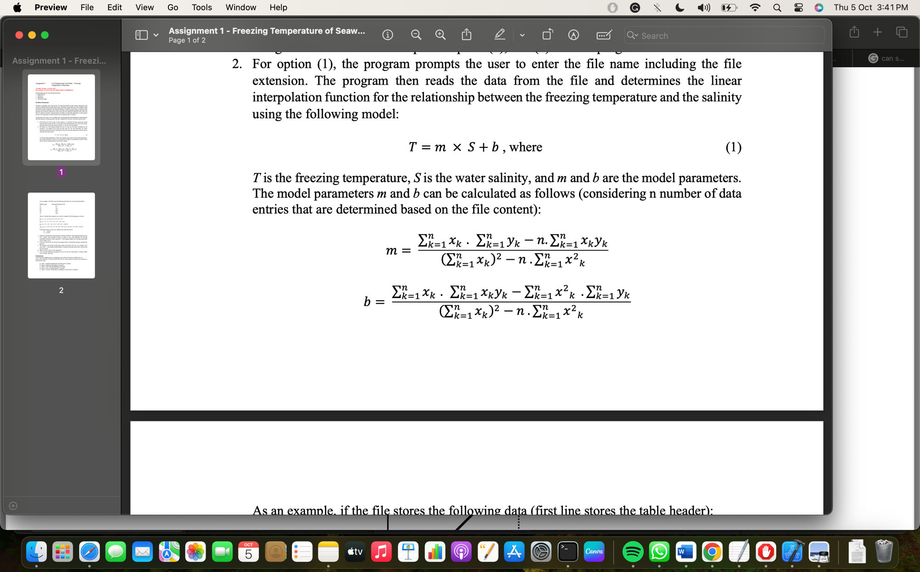

Where n- the number of record pairs of temperature and salinity readings within a given dataset, and xk represents a salinity measurement corresponding to a freezing temperature yk.

The graph above represents the Linear regression for the model T = -0.0978 * S + 32.0347 based on the following data set:

Salinity (ppt) Freezing Temperature (F)

0 32

10 31.1

20 30.1

24.7 29.6

30 29.1

35 28.6

The inputs/outputs may be represented as follows:

The user upon starting the program will be presented with a menu that gives them three options and will be asked to select one of the three options.

**Option 1**

*Inputs*

* A file containing the dataset, salinity reading, xk  and freezing Temperature reading, yk from file

*Outputs*

* Model parameters m and b in the form 𝑇 = 𝑚 × 𝑆 + 𝑏.

**Option 2**

*Inputs*

* Salinity reading, S

*Outputs*

* Freezing temperature, T.

*Alternative block Diagram*

**Option 1**

m

File

b

**Option 2**

Freezing temperature, T

Salinity, S

***STEP 3: Test Cases and Algorithm Design***

1. ***Test Cases***

***Test Case 1: Menu Validation***

***Test Case1.0: Menu Output***

The program will output the following***:***

Freezing Temperature of Seawater

Welcome to the Linear Regression Model System

1. : Calculate Linear Regression Model.
2. : Calculate Freezing Temperature.
3. : Exit Program.

Please choose an option from the menu above:

***Test Case 1.1: User Selects Option 1***

The program will output the following***:***

Enter the data file name with extension:

***Test Case 1.2: User Selects Option 2***

The program will output the following***:***

Enter the salinity of the water:

***Test Case 1.3: User Enters character “a”***

The program will output the following***:***

Error! Please choose an option in the menu!!

***Test Case 1.4: User enters string “one”***

The program will output the following***:***

Error! Please choose an option in the menu!!

***Test Case 1.5: User Enters Option 2 without creating a model First***

ERROR! Please calculate Linear Regression Model first!

Freezing Temperature of Seawater

Welcome to the Linear Regression Model System

1. : Calculate Linear Regression Model.
2. : Calculate Freezing Temperature.
3. : Exit Program.

Please choose an option from the menu above:

***Test Case 2: Linear Model***

Below shows a test dataset file (data.txt) of salinity and freezing temperature readings.

|  |  |
| --- | --- |
| Salinity (xk/ppt) | Freezing Temperature (yk/F) |
| 0 | 42 |
| 20 | 41.1 |
| 30 | 40.1 |
| 34.7 | 39.6 |
| 40 | 39.1 |
| 45 | 38.6 |

To evaluate the model parameters m and b, from the dataset above we get the following summations:

$$\sum_{k=1}^{n}{x_{k}}=0+20+30+34.7+40+45=169.7$$

$$\sum_{k=1}^{n}{y_{k}}=42+41.1+40.1+39.6+39.1+38.6=240.5$$

$$\sum_{k=1}^{n}{x_{k}^{2}}=0^{2}+{10}^{2}+{20}^{2}+{30}^{2}+{34.7}^{2}+ {40}^{2}+ {45}^{2}=6129.09$$

$$\sum_{k=1}^{n}{x_{k}y_{k}}=0*43+20*41.1+30*40.1+34.7*39.6+40*39.1+45*38.6$$

$$=6700.12$$

Using the above summations, the following model is produced:

m = -0.0767422

b = 42.2539

***Test Case 2.1: User Enters existing file:***

The program prompt the user as follows***:***

Enter the data file name with extension: data.txt

The program will output the following***:***

The linear regression model is:

T= -0.0767422 * S + 42.2539

***Test Case 2.2: User Enters file that doesn’t exist:***

The program prompt the user as follows***:***

Enter the data file name with extension: file.txt

The program will output the following***:***

ERROR! Could not open file!

Program ended with exit code: 1

***Test Case 3: Freezing Temperature***

The following table provides a set of test cases that can be used to test the algorithm and software.

|  |  |  |
| --- | --- | --- |
| **Test Case** | **Salinity(S/ppt)** | **Freezing Temperature (T/F)** |
| 3.1 | 0 | 42.2539 |
| 3.2 | 2 | 42.1004 |
| 3.3 | 50 | 38.4167 |
| 3.4 | 1000 | -34.4883 |
| 3.5 | -10 | Error! Please enter a non-negative integer! |
| 3.6 | k | Error! Please enter a non-negative integer! |

***Test Case 4: Exit Program***

Upon exiting the program, the following message should be printed:

Thank you for using our system…

Goodbye!

1. Pseudocode Algorithm

*Assign 0 to x, y, sumx, sumy, prod_xy, squae_x, m, b, ctr, choice, indicator*

*Assign false to isValidInput*

*Repeat*

*Print “Freezing Temperature of Seawater”, newline*

*Print “Welcome to Linear Regression Model System”, newline*

*Print “1 : Calculate Linear Regression Model”, newline*

*Print “2 : Calculate Freezing Temperature”, newline*

*Print “0 : Exit Program”, newline*

*Repeat*

*Print “Please choose an option from the menu above: ”*

*Read choice*

*If input fails then*

*Assign false to isValidInput*

*Print “Error! Please enter an integer”, newline*

*Clear input*

*Otherwise*

*Assign true to isValidInput*

*Endif*

*While isValidInput is equal to false*

*If choice is equal to 0 then*

*Print “Thank you for using our system…”, newline, “Goodbye!”*

*Otherwise if choice is equal to 1 then*

*Print “Enter file name with extension: “*

*Read file*

*Create input file stream as inFile*

*Open file using stream inFile*

*If inFile fails to open then*

*Print “Error! Could not open file!”, newline*

*Exit program*

*End if*

*Repeat while not at the end of file*

*Read salinity from file into x*

*Read temperature from file y*

*If inFile fails then*

*Clear input*

*Continue to next line in file*

*Endif*

*sum_x = sum_x + x*

*sum_y = sum_y + y*

*square_x = square_x + x2*

*prod_xy = prod_xy + x*y*

*ctr = ctr + 1*

*End while*

*Close file*

*m = sum_x × sum_y - ctr × prod_xy / (sum_x)2 - ctr × square_x*

*b = sum_x × prod_xy - square_x × sum_y / (sum_x)2 - ctr × square_x*

*Assign 1 to indicator*

*Print “The linear regression model is: ”, newline*

*Print “T =”, m, “* S +”, b*

*Otherwise if choice is equal to 2 then*

*If indicator is equal to 1*

*Repeat*

*Print “Enter the salinity of the water: ”*

*Read x*

*If input fails or x is less than 0 then*

*Assign false to isValidInput*

*Print “Error! Please enter an integer”, newline*

*Clear input*

*Otherwise*

*Assign true to isValidInput*

*Endif*

*While isValidInput is equal to false*

*y = m * x + b*

*Print “The freezing temperature of water with salinity”, x, “ppt*

*is:”, y,“F”, newline*

*Otherwise*

*Print “ERROR! Please calculate Linear Regression Model*

*first!”, newline*

*Continue to main menu.*

*Endif*

*Otherwise*

*Print “Error! Please choose an option in the menu!”, newline*

*Continue to main menu.*

*End if*

*While choice is not equal to 0*

***STEP 4: Implementation***

//

// LRS_salinity_temp.cpp

// Freezing Temperature of Seawater

//

// Created by Demarce Williams on 04/10/2023.

// Description: The program computes the linear regression model based on a given data set of temperature and salinity readings and estimate the freezing temperatures based on a given salinity value of water using the computed model.

/*___________________________________________________________________________________________________________________________*/

#include <iostream> //Standard input/output library

#include <fstream> //Allows for file manipulation

#include <string> //Allows for string data manipulation

#include <cmath> //Provides math functions

#include <limits> //Allow to obtain properties of numeric data types

using namespace std;

int main() {

//Object declaration

// x and y represents the salinity and frezing temperature, respectively

double x(0), y(0);

//Stores the summations of the respective parameters

double sum_x(0),sum_y(0),prod_xy(0), square_x(0);

//Stores the calculated model parameters m and b in the regression model T = m * S + b

double m(0), b(0);

//Counter to store total iterations and choice to store user selection from menu

int ctr(0), choice(0);

//n stores the total number of data sets and indicator tells whether a regression model is present

int indicator(0);

//Stores file name with extension

string file("");

//Checks validity of input

bool isValidInput = false;

//Main menu loop

do{

// Program title and Welcome message

cout << "\nFreezing Temperature of Seawater\n";

cout << "\nWelcome to the Linear Regression Model System\n";

// Prints menu to user

cout << "\n1 : Calculate Linear Regression Model.\n";

cout << "2 : Calculate Freezing Temperature.\n";

cout << "0 : Exit Program.\n";

//Ensures user input is of integer type

do{

// Prompts the user to make a selection from menu

cout << "\nPlease choose an option from the menu above: ";

cin >> choice;

//Checks Validity of input

if(cin.fail()){

isValidInput = false;

cout << "\nError! Please enter an integer!\n";

//clears characters in input buffer up to the limit or upon encountering a newline character.

cin.clear();

cin.ignore(numeric_limits<streamsize>::max(),'\n');

}else{

isValidInput = true;

}//End of if statement

}while(!isValidInput);

switch(choice){

case 0:

cout << "\nThank you for using our system...\n";

cout << "Goodbye!\n" << endl;

break;

case 1:{

// Prompts user to enter file name with extension and stores user input in string variable file.

cout << "\nEnter the data file name with extension: ";

cin >> file;

// Open input file stream for given file.

ifstream inFile;

inFile.open(file);

//Checks if file was succesfully opened.

if(inFile.fail()){

cout << "\nERROR! Could not open file!\n" << endl;

exit(1);

}//End of if statement

//Loops through the file until end of the file is reached

while(!inFile.eof()){

// Reads values of salinity and temperature from file into x and y, respectively

inFile >> x >> y;

//Skip header and any non-numeric character

if(inFile.fail()){

//clears characters in input buffer up to the limit or upon encountering a newline character.

inFile.clear();

inFile.ignore(numeric_limits<streamsize>::max(),'\n');

continue;

}//End of if statement

//Calculate the summations of teh respective parameters using salinity and temperature data from file

sum_x += x;

sum_y += y;

square_x += pow(x,2);

prod_xy += x * y;

//Increment counter by 1

ctr++;

}//End of while loop

// Calculate Linear Regression model parameters

m = ((sum_x * sum_y) - (ctr * prod_xy)) / (pow(sum_x, 2) - (ctr * square_x));

b = ((sum_x * prod_xy) - (square_x * sum_y)) / (pow(sum_x, 2) - (ctr * square_x));

//Indicates to program that regression model was calculated

indicator = 1;

//Output Linear Regression model to user

cout << "\nThe linear regression model is: \n" << "T = " << m << " * S + " << b << endl;

break;

}case 2:{

//Check if parameter m or the slope is given to ensure that regression model is already

if (indicator == 1){

//Ensure salinity is a non-negative integer and not a character

do{

//Prompt suer to enter salinity of water

cout << "\nEnter the salinity of the water: ";

cin >> x;

if(x < 0 || cin.fail()){

isValidInput = false;

cout << "\nError! Please enter a non-negative integer!\n";

//clears characters in input buffer up to the limit or upon encountering a newline character.

cin.clear();

cin.ignore(numeric_limits<streamsize>::max(),'\n');

}else{

isValidInput = true;

}//End of if statement

}while(!isValidInput);

//Calculate the freezing temperature of the weter.

y = (m * x) + b;

//Output freezing temperature to the user

cout << "\nThe freezing temperature of water with salinity " << x << " ppt is: " << y << " F" << endl;

}else{

cout << "\nERROR! Please calculate Linear Regression Model first!\n";

continue;

}//End of if statement

break;

}default:{

cout << "\n\nError! Please choose an option in the menu!!\n\n";

continue;

}//End of case 2 block

}//End of switch statement

}while(choice != 0); // End of main menu loop

//Exit Program

return 0;

}//Main function

***STEP 5: Tests and Verification***

***Test Case 1: Menu Validation***

***Test Case 1.0: Menu Output***

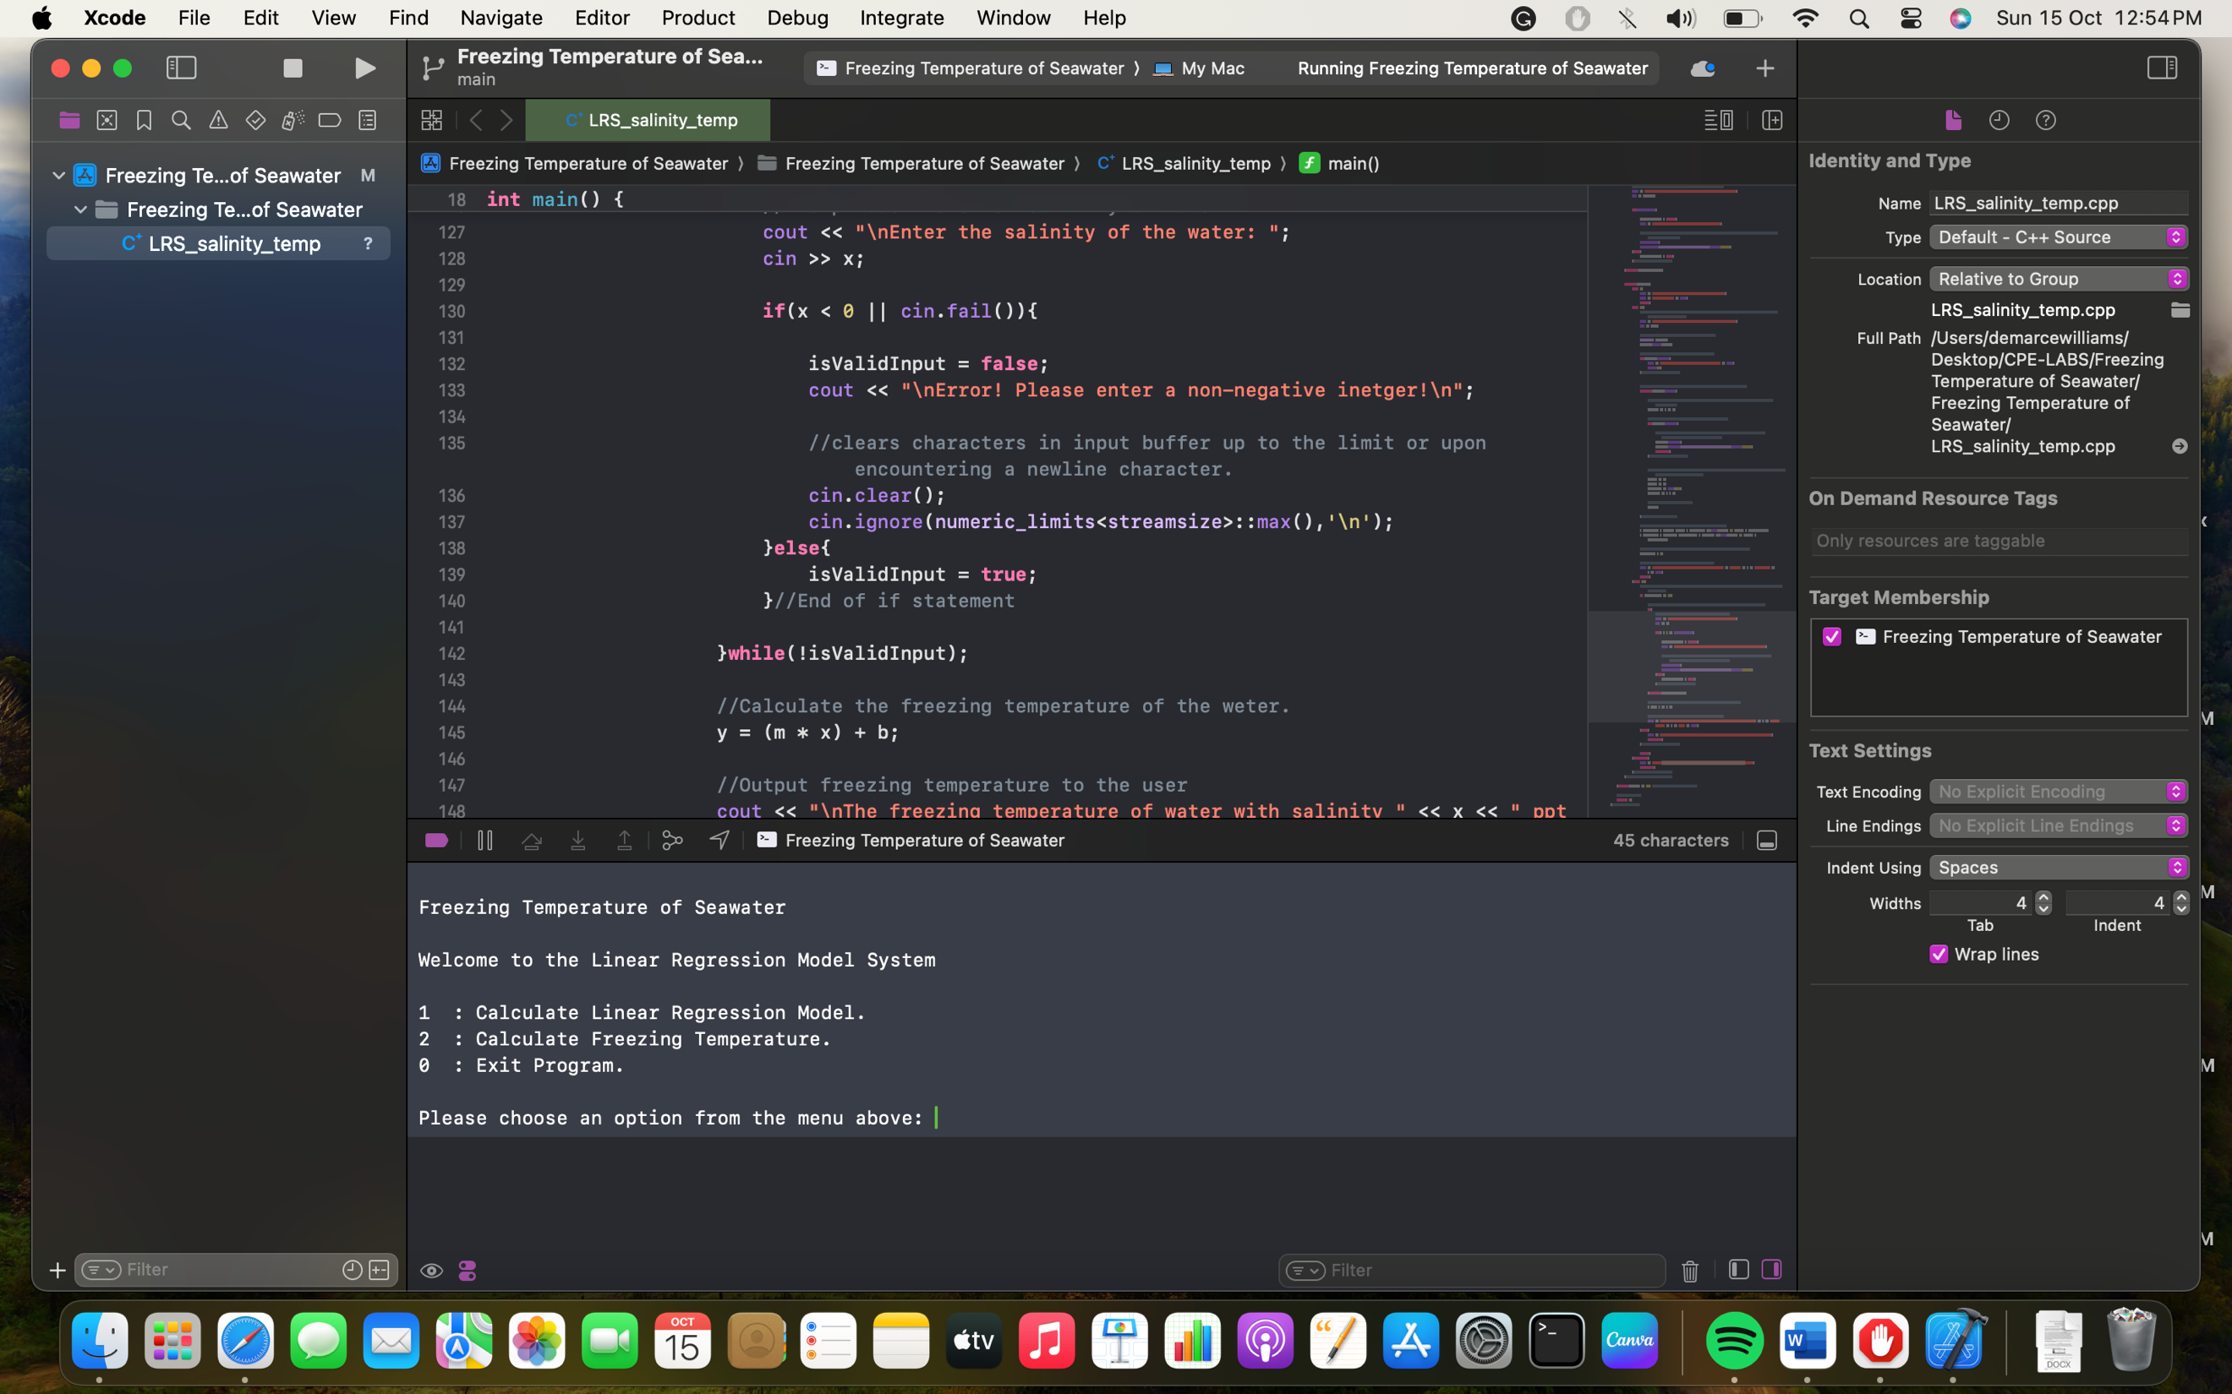

, which is in agreement with the expected test case.

***Test Case 1.1: User Selects Option 1***

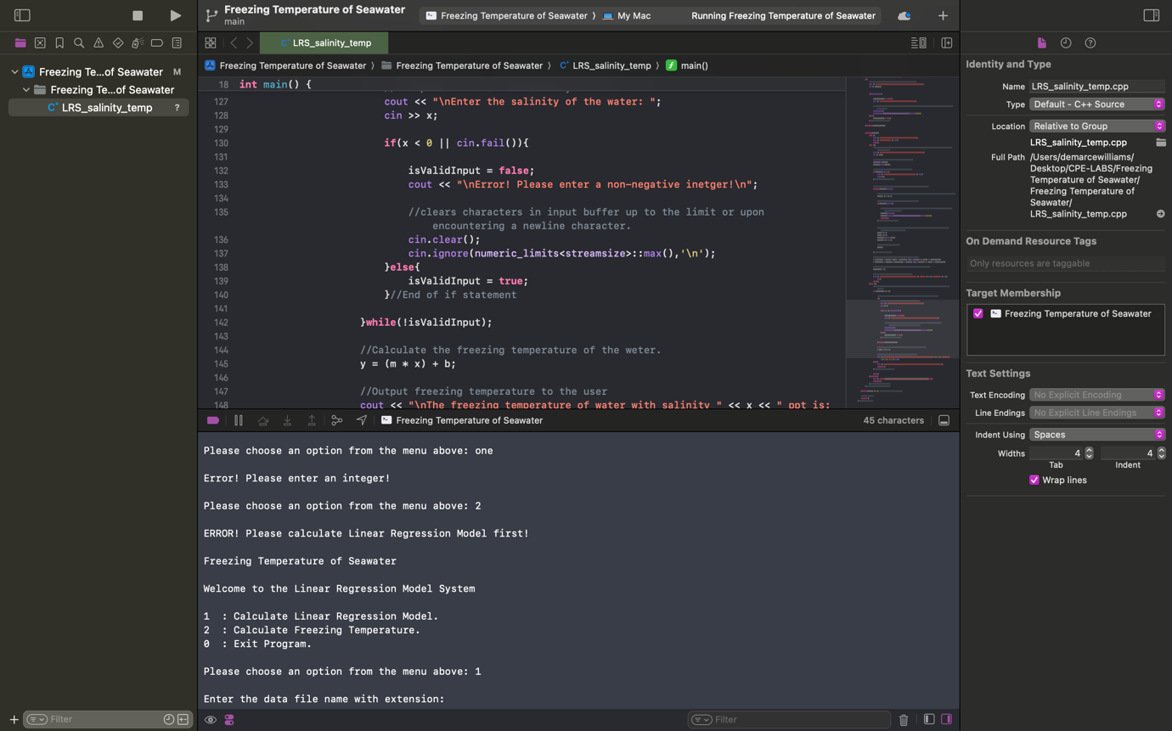

, which is in agreement with the expected test case.

***Test Case 1.2: User Selects Option 2***

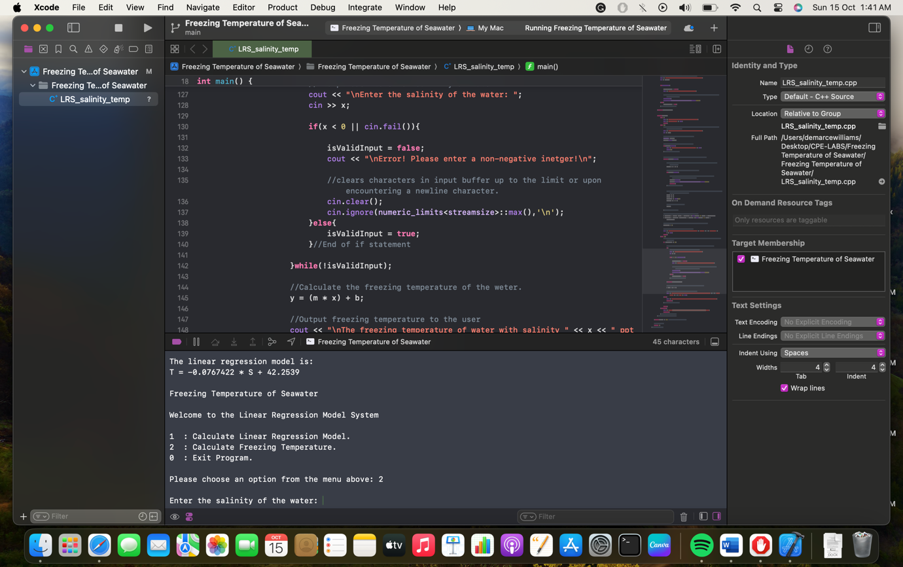

, which is in agreement with the expected test case.

***Test Case 1.3: User Enters character “a”***

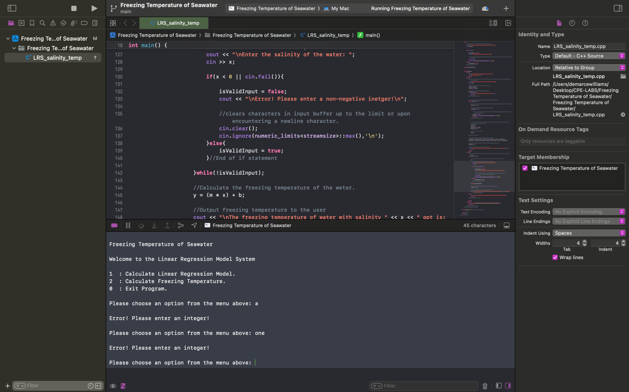

, which is in agreement with the expected test case.

***Test Case 1.4: User enters string “one”***



, which is in agreement with the expected test case.

***Test Case 1.5: User Enters Option 2 without creating a model First***

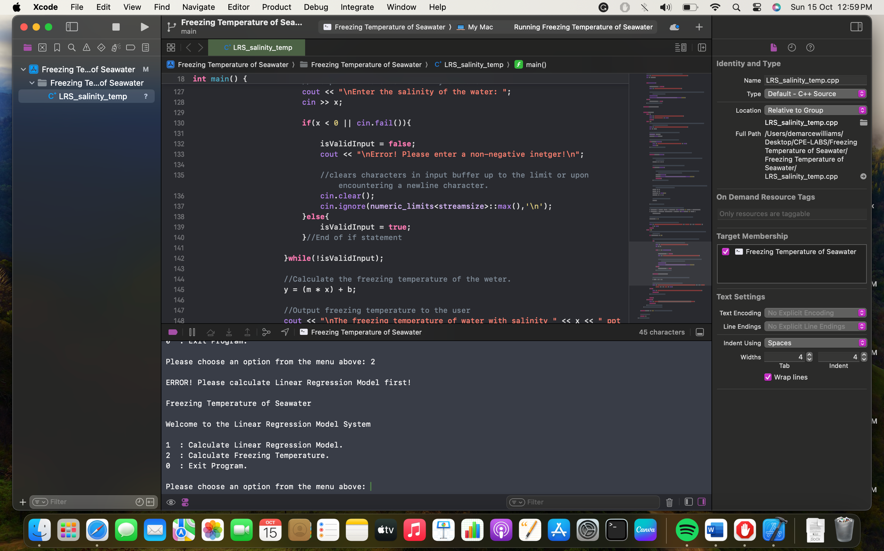

, which is in agreement with the expected test case.

***Test Case 2: Linear Model***

***Test Case 2.1: User Enters existing file:***

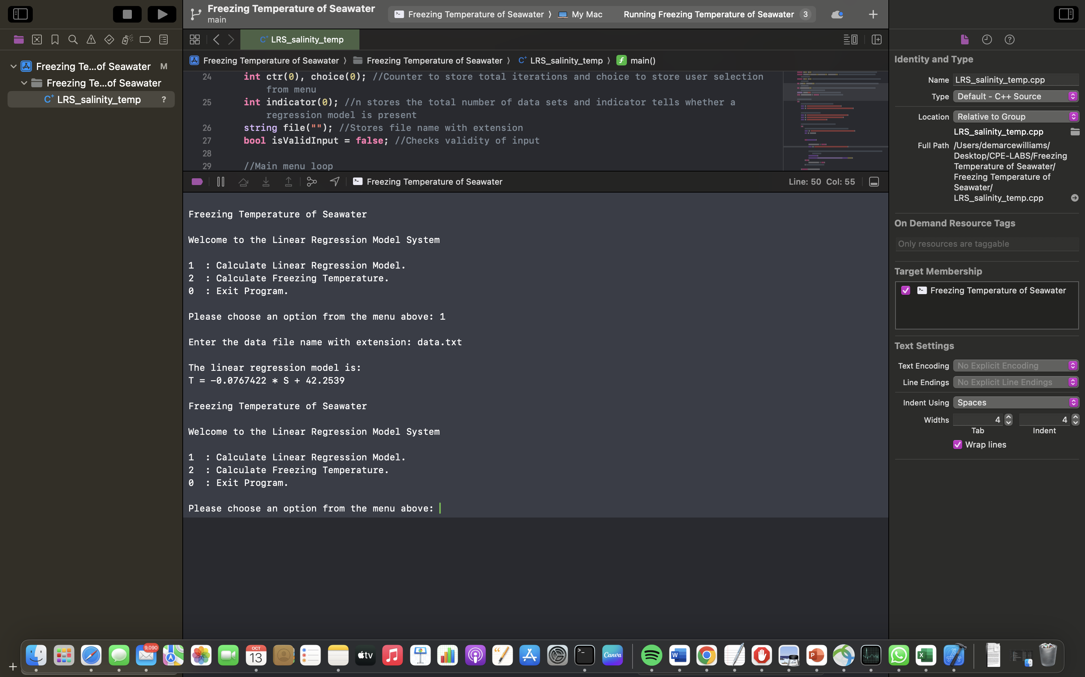

, which is in agreement with the expected test case.

***Test Case 2.2: User Enters file that doesn’t exist:***

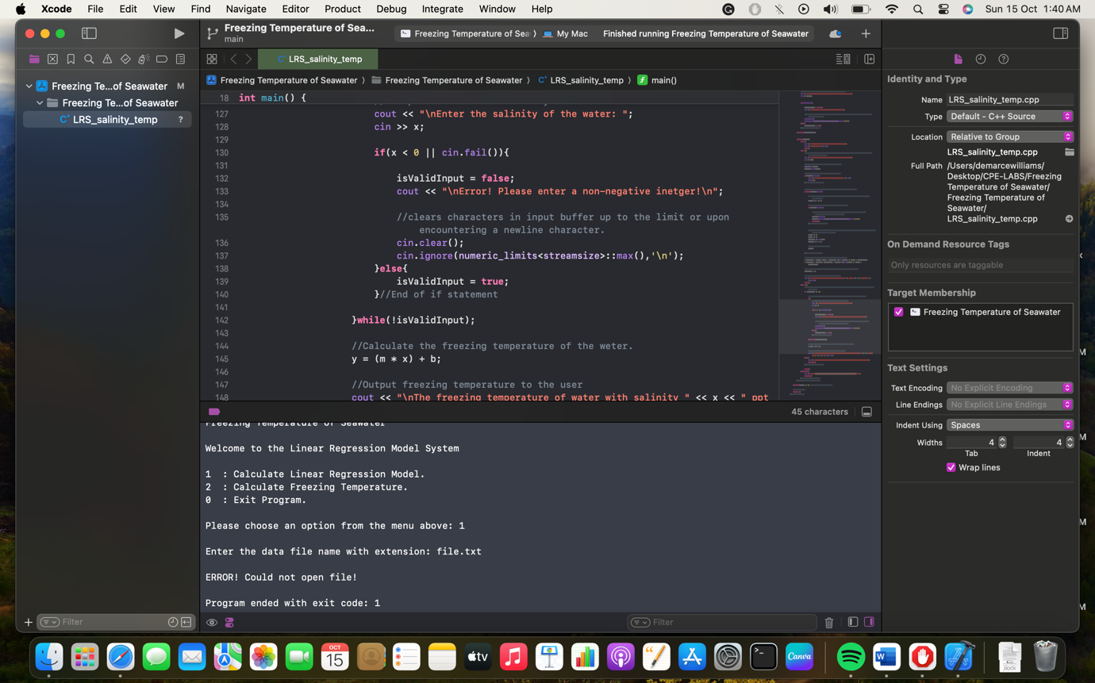

, which is in agreement with the expected test case.

**Test Case 3**

**Test Case 3.1: For salinity of 0, output:**

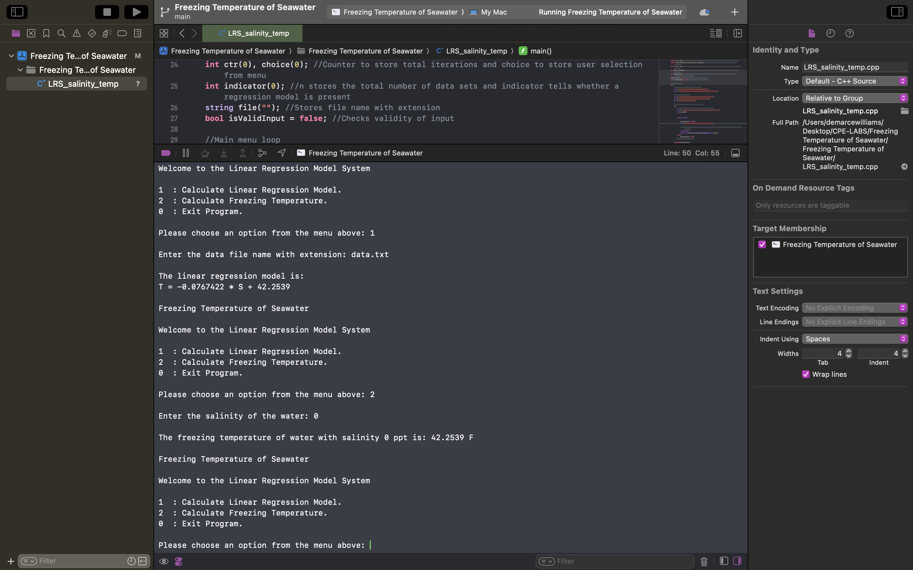

, which is in agreement with the expected test case.

**Test Case 3.2:** **For salinity of 2, output:**

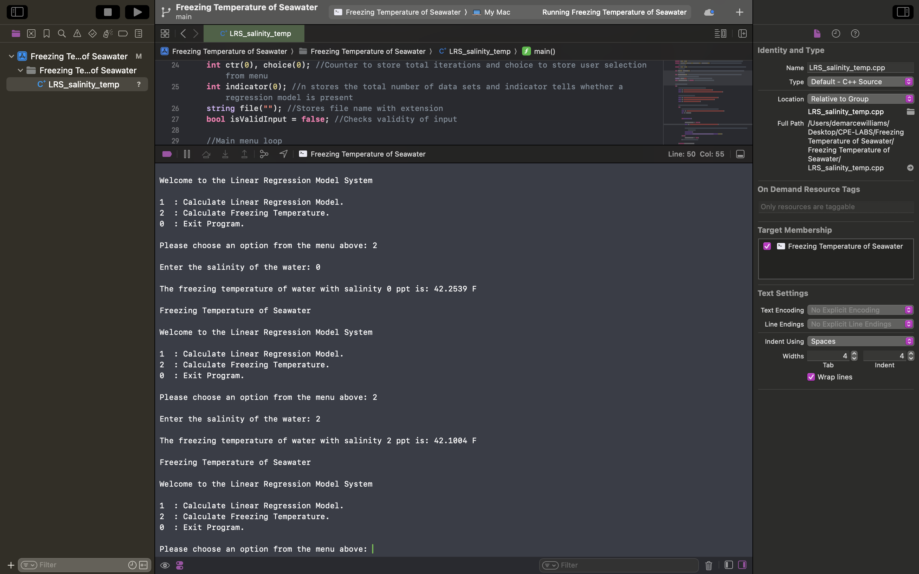

, which is in agreement with the expected test case.

**Test Case 3.3:** **For salinity of 50, output:**

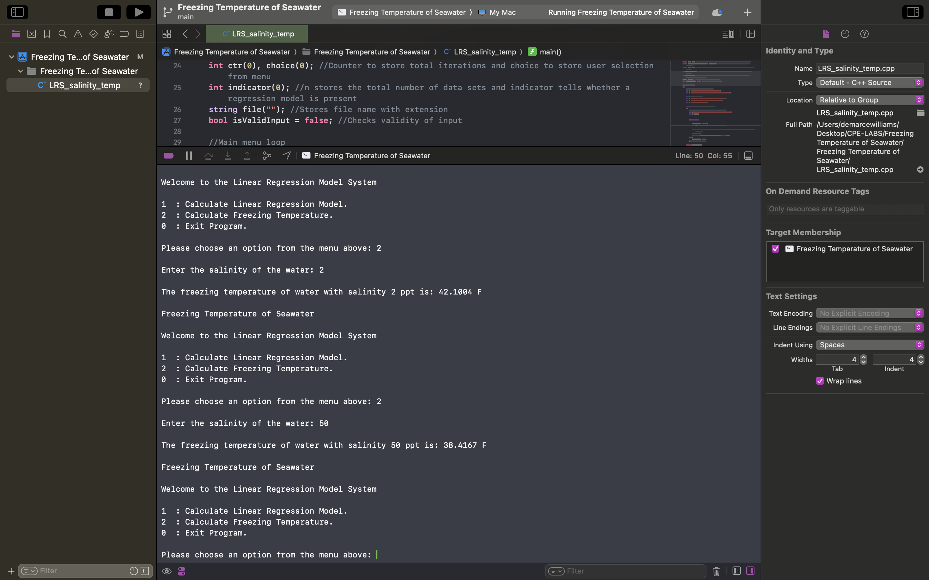

, which is in agreement with the expected test case.

**Test Case 3.4:** **For salinity of 1000, output:**

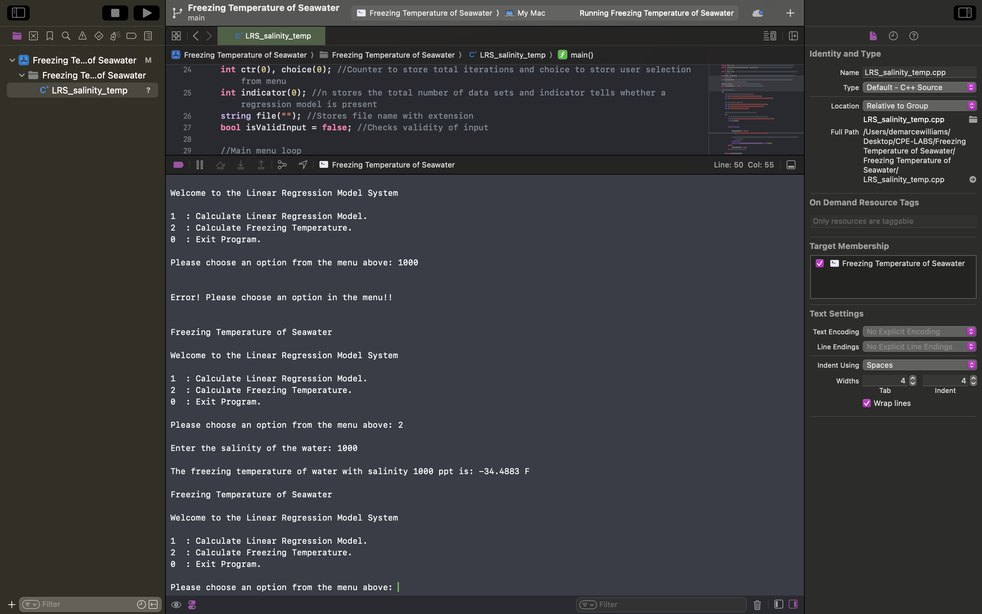

, which is in agreement with the expected test case.

**Test Case 3.5:** **For salinity of -10, output:**

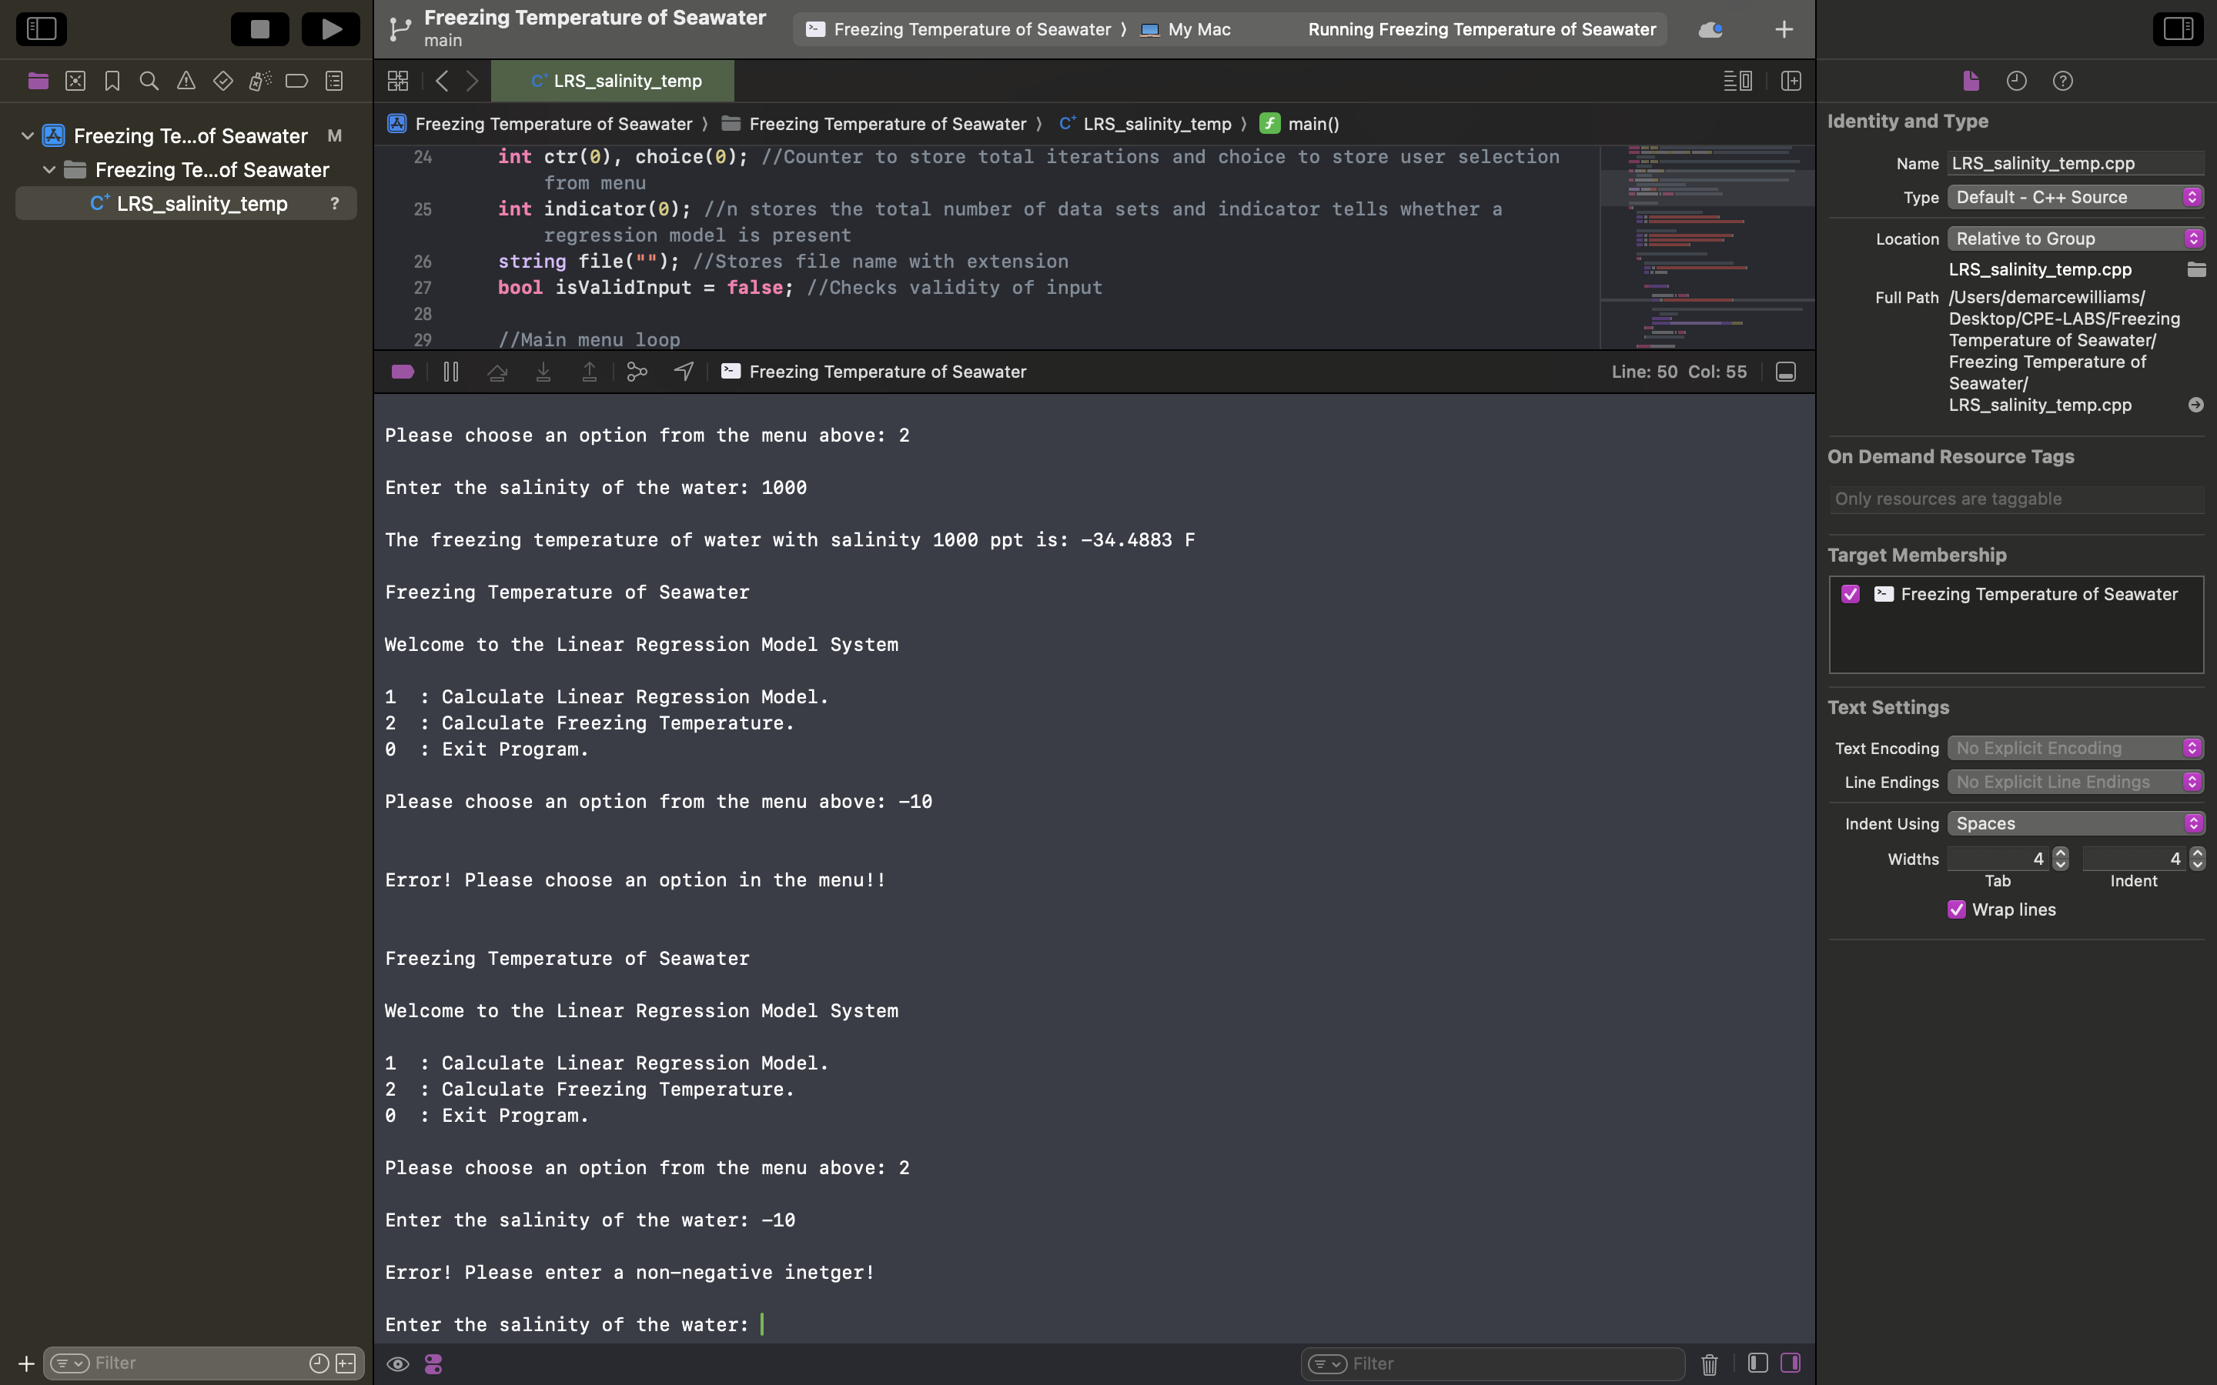

, which is in agreement with the expected test case.

**Test Case 3.6:** **For salinity of k, output:**



, which is in agreement with the expected test case.

**Test Case 4: Exit Program**

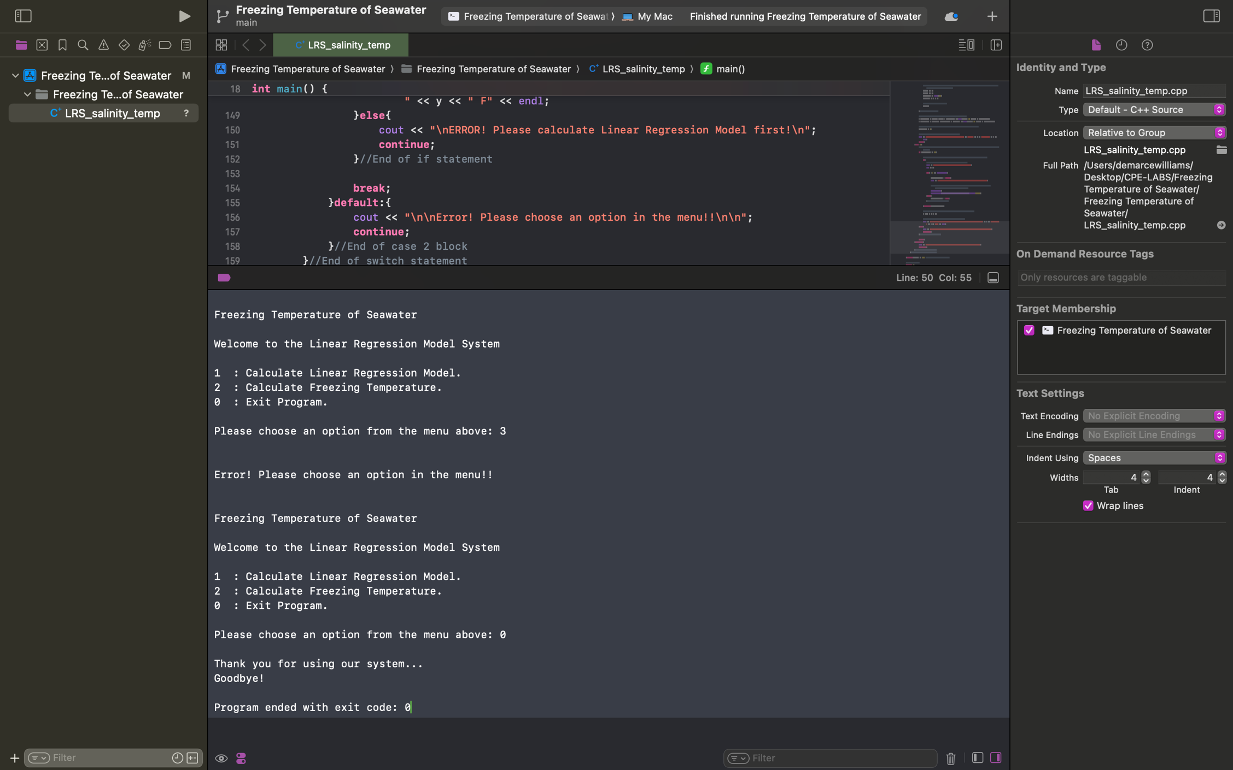

, which is in agreement with the expected test case.

***The User’s Guide***

* *To execute the program, compile and run the code found in the file named* [*LRS_salinity_temp.cpp.*](https://drive.google.com/file/d/1YMOH0DM3thns9ARotqQQfDNEidH3RAHB/view?usp=share_link)
* *The user will be printed a menu and prompted to make a selection,*
* *User may select option 1 to calculate the linear regression model, in which they will be asked to provide a file.*
* *The output displayed on the screen will be the linear regression model based on the file data.*
* *User may select option 2 to calculate freezing temperature, in which they will be asked to enter a non-negative salinity value.*
* *The output displayed on the screen will be the corresponding freezing temperature.*
* *User may select 0 to terminate the program.*
* *User must ensure that the data file provided exists, otherwise the program will be terminated. Furthermore, ensure to enter valid selections from the menu and for salinity as the program will not allow the process to continue until a valid input is entered.*
* *The program assumes that the values entered are integers, any decimal values will be truncated an may result in an unexpected error.*